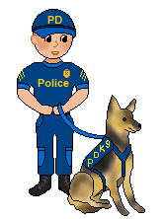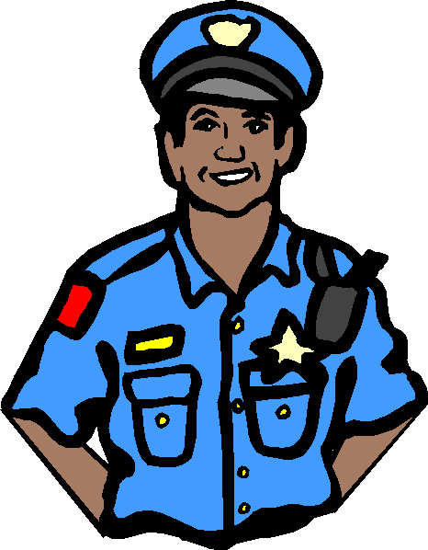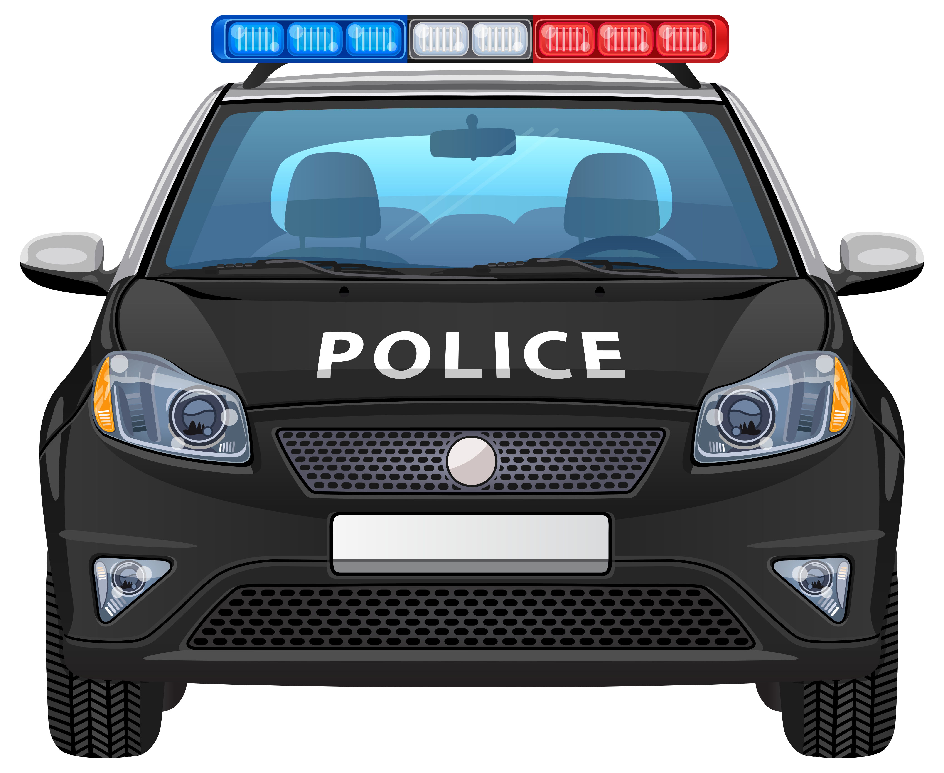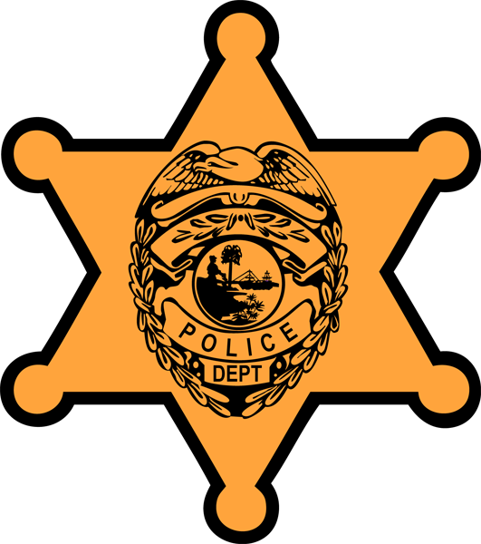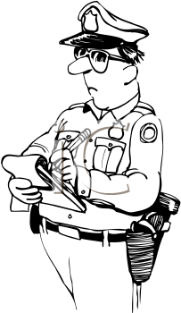

[Street Address] [City], [State] [Postal Code]

{Phone Number}  
[Web Address]

#### **Easy to follow instructions to keep you & your family safe**

# **How to Act when the Police Pull You Over**

9. Be polite, and do not argue if you are given a ticket.

There’s plenty of time later in traffic court if you choose to contest it. Instead, thank the officer and remain in control of your emotions. If you believe that you were pulled over for an illegal reason, or that the officer did something that was illegal, do not address it with the officer. Try and get or remember the officer’s name for later. Then contact an attorney.

## 8. Know when an officer can legally search your car.

## In the USA, moving vehicles are subject by law enforcement to search with probable cause after a traffic stop. If the officer sees any illegal objects in plain view, he or she can search the part of the vehicle that the objects are in, and arrest you if necessary. If an officer asks you for permission to search your vehicle, you do not have to say yes. If you say no, the officer may try to establish probable cause.

### **6. Keep your answers non-committal and brief.**

### Be polite at all times, and refer to the officer as “officer”. You may want to ask the officer what his or her name is. Open-ended questions can get you into trouble. The officer may be trying to extract admissions out of you that can be used against you in court. He or she will include any answers you make to him in his or her police report. Additionally, as personal cameras become more standard with police officers, your interaction will be recorded.

### **7. Follow any orders given by the officer.**

### Refusing to follow an officer’s orders will identify you as wither resistant or rebellious. This gives the officer the belief that he may have to use force to make you obey their orders.

Your Precinct Info Here

1. Know Your Rights

A police officer can pull you over for any traffic violation, no matter how minor. They can even follow you and wait for you to commit a traffic violation. Never fight with the police officer or act in a threatening or hostile manner. If you do, the officer could react by arresting you or retaliating in some other way.

A police officer cannot pull you over because of your age, race or the type of car you drive. If you believe that you’ve been pulled over for an illegal reason, record the interaction between yourself and the police officer, if possible. Simply place your cell phone on your dashboard and hit “record”.”.

**2. Look for a convenient spot to pull over***.*

Slow down, put your turn signal on, and pull over to the right. This will signal to the officer that you intend to pull over. Try to find a close parking lot or wide shoulder of the road. Many officers will appreciate the consideration. Take the keys out of the ignition and place them on the dash.

If it’s dark and you are alone, you have the right to drive to a well-lit area, such as a gas station, before stopping. If you plan to drive until you find a safe place, dial 911. Let them know that you are being pulled over by a police officer and that you are driving until you find a well-lit safe place to pull over. The 911 operator will communicate this information to the police officer*.*

**4. Roll down your driver’s side window and any tinted windows.**

If it is dark, turn on interior lights. Make all your movements slowly. The officer is watching you carefully to make sure you’re not drawing a weapon or hiding something. Do not reach for anything in the passenger compartment of your vehicle or under your seat. As the officer approaches, put your hands on the steering wheel where the officer can see them. **5. Don’t Speak First**

When the officer comes over to your car, he will usually ask for your license and registration. He is not obligated to tell you why he pulled you over before you comply. When you move your hands, tell the officer that you are getting your license and registration. Get them slowly and deliberately. If you’re in a dark area, the officer will follow your hands with his flashlight. Finish this process before anything else, then put your hands back on the wheel. While the officer checks your license and vehicle status, keep your hands on the steering wheel.

If you don’t have a license or registration, the officer can arrest you for driving without them or can give you a ticket.

**3. Relax**

Even though getting pulled over by a police officer is scary, you will be okay even if you get a traffic ticket. Take a deep breath and remember that police officers are not evil or scary. They are there to help protect everyone.